CP Club 365 Days Challenge

**Programming language – C++**

**Problem Statement**

<https://www.codechef.com/problems/POOK>

Git :- <https://github.com/Vedantbharad2603/CP_club_365_Days>

**Your Code**:

// 0x142Day of 0x365Days challenge

// VEDANT BHARAD

// 09-03-2023

#include <iostream>

using namespace std;

int main() {

    int t;

    cin >> t;

    while (t--) {

        int n;

        cin >> n;

        if (n == 1) {

            cout << 1 << endl;

        } else if (n < 4) {

            cout << n - 1 << endl;

        } else {

            cout << n << endl;

        }

    }

    return 0;

}

**Output (Screen Shot)**:

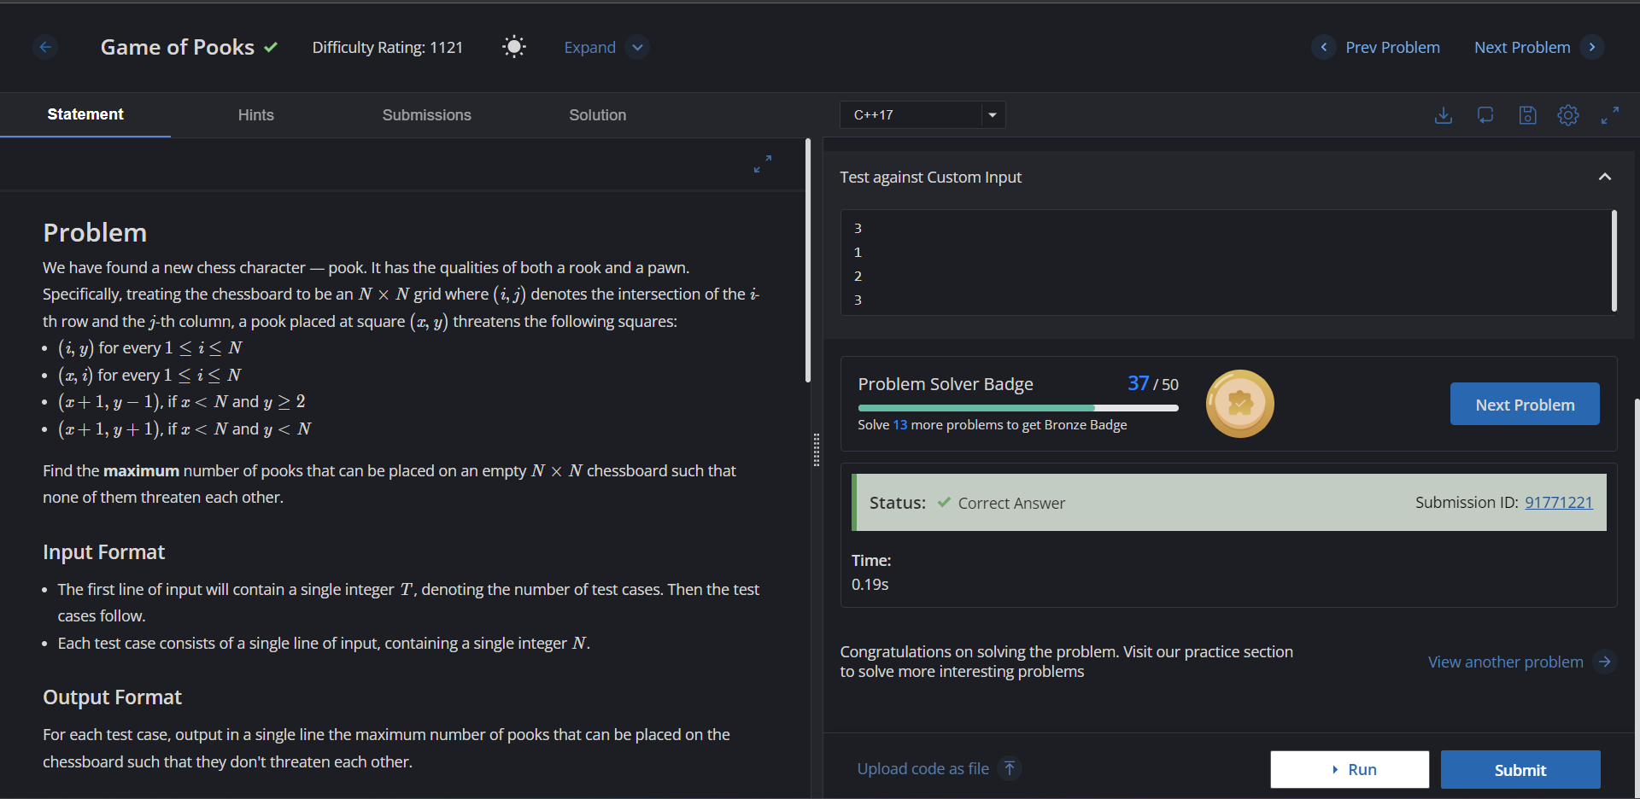

**Understanding about problem:**

-> In this task I need to Find the maximum number of pooks that can be placed on an empty array

Note: If you can't understand the problem, feel free to contact us and we'll help you. Please don't copy and paste from anywhere.

ALL THE BEST

Team CP Club